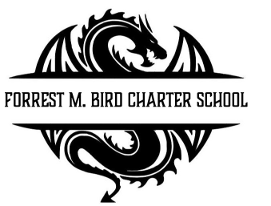
Board Meeting
Forrest M. Bird Charter High School
615 S. Madison,
Sandpoint, ID 83864
Date: May 26 , 2026

 | Board Meeting Minutes
Minutes taken by | Mary Jensen / Collin Day
Board members Present | Susan Roberts, Shawn Burns, Stephanie Hawkins
Excused Board Members
Staff present | Mary Jensen, Gretta Warren, Amber Williams
Guests
Call to Order | Meeting Called to Order at ; Quorum established at

Minutes | Action Item: Approval of Minutes:  - Motion – Stephanie Hawkins  - 2nd – Susan Roberts  Approved: Unanimously
Public Comment | None

Financials | - Approval of Financial Reports  - Motion: Susan Roberts  - 2nd – Stephanie Hawkinds  - Unanimous  - Mountain West Bank Loan Revision of Terms  - Motion: Susan Roberts  - 2nd – Stephanie Hawkinds  - Unanimous  - Information – 2025/26 Budget update for Next school year
Open Business | - Kevin Kless Van Driver Approval  - Motion: Susan Roberts  - 2nd – Stephanie Hawkins  - Information: Ridley Village Fencing  - Presentation: New Behavioral Plan 26/27 School Year  - Revision of School Calendar  Move last day of school from June 10th to June 9th  - Motion: Stephanie Hawkins  - 2nd: Susan Roberts  - Unanimous  - Work Session: Board On Boarding Process – Review  - June Board Meeting Date  - Move to 17th  - Motion: Stephnie Hawkins  - 2nd: Susan Roberts  - Unanimous
Executive Session (waived) | - Executive Director Eval  - Looks awesome  - Will work virtually in January  - Salary negotiated  - Approve with edits  Motion: Susan Roberts  2nd: Stephanie Hawkins  Unanimous
Adjourn | - Motion: Collin Day  - 2nd : Susan Roberts  - Unanimous  End at 6:35

Next Board Meeting | June 17th, 2026

Respectfully Submitted: Collin Day

Date: July 15, 2026

Signed:____________________________
Board Chair, date

Signed: ___________________________

Board Secretary, date

