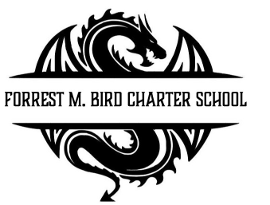
Board Meeting
Forrest M. Bird Charter High School
615 S. Madison,
Sandpoint, ID 83864
Date: June 17, 2026

 | Board Meeting Minutes
Minutes taken by | Collin Day
Board members Present | Susan Roberts, Shawn Burns
Excused Board Members | Stephanie Hawkins
Staff present | Mary Jensen, Gretta Warren
Guests
Call to Order | Meeting Called to Order at 4:00, Quorum established at 4:00

Minutes | Action Item: Approval of Minutes:  - Motion – Susan Roberts  - 2nd - Collin Day  Approved: Unanimously
Public Comment | NA

Financials | - Approval of Financial Reports  - Motion: Susan Roberts  - 2nd : Collin Day  - Unanimous  - Approval of 26/27 budget  - Motion: Susan Roberts  - 2nd : Collin Day  - Unanimous  - Information – 2025/26 Budget update for Next school year
Open Business | - Scout Gates Charter Teacher Certificate  - Motion: Susan Roberts  - 2nd: Collin Day  - Unanimous  - Election of Officers 26/27  - Motion to stay as is  - Susan Roberts  - 2nd : Collin Day  - Unanimous  - Oaths of Office (Chair / Board combined)”:  - Motion to do it all at once:  - Collin Day  - 2nd Susan Roberts  - Unanimous  - Selection of Meeting Dates 26/27  - Motion: Susan Roberts  - 2nd: Collin Day  - Unanimous
Adjourn | - Motion: Sussan Roberts  - 2nd : Collin Day  - Unanimous  End at 4:20

Next Board Meeting | August 19th, 2026

Respectfully Submitted: Mary J. Jensen

Date:

Signed:____________________________
Board Chair, date

Signed: ___________________________

Board Secretary, date

