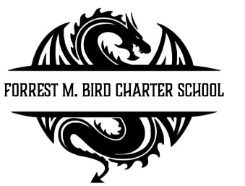
Board Meeting
Forrest M. Bird Charter High School
615 S. Madison,
Sandpoint, ID 83864
Date: Feb 26 , 2026

 | Board Meeting Minutes
Minutes taken by | Collin Day
Board members Present | Susan Roberts, Shawn Burns, Stephanie Hawkins
Excused Board Members
Staff present | Mary Jensen, Gretta Warren, Amber Williams
Guests | Cody Thompson
Call to Order | Meeting Called to Order at 4:36; Quorum established at 4:36

Minutes | Action Item: Approval of Minutes:  - Motion – Stephanie Hawkins  - 2nd – Susan Roberts  Approved: Unanimously
Public Comment | Written Public Comment #1 – From Lora Scott – In favor of banning energy drinks from FBCS.  Written Public Comment #2 – From Mark Webber – In favor of banning energy drinks from FBCS; in favor of selling Lotus Energy drinks for culinary arts fund raising.

Student A: Disciplinary Review | No show - rescheduled
Financials | - Approval of Financial Reports  - Motion: Stephanie Hawkins  - 2nd – Susan Roberts  - Unanimous  - Close STCU CD in April  - Motion: Susan Roberts  - 2nd – Stephanie Hawkins  - Unanimous  - Information – 2025/26 Budget – anticipate a shortfall, Greta and Mary will be working on the budget on 3/6 if any board members would like to attend (as long as board members do not make a quorum).
Open Business | - Energy Drink Ban - decline  - Motion: Susan Roberts  - 2nd – Stephanie Hawkins  - Unanimous  - Information - Open Seats for Lottery – to be emailed  - Admin and Non-Cert Salary Matrix  - Motion to table to March – Susan Roberts  - 2nd – Stephanie Hawkins
Stop the Madness | - Motion to Close 5:22  - Motion – Stephanie Hawkins  - 2nd – Susan Roberts  - Unanimous

Next Board Meeting | March 26th, 2026

Respectfully Submitted: Collin Day

Signed:____________________________
Board Chair, date

Signed: ___________________________

Board Secretary, date

