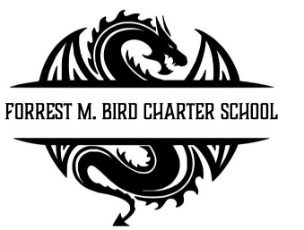
Board Meeting
Forrest M. Bird Charter High School
615 S. Madison,
Sandpoint, ID 83864
Date: Jan. 29, 2026

 | Board Meeting Minutes
Minutes taken by | Collin Day
Board members Present | Susan Roberts, Shawn Burns
Excused Board Members | Stephanie Hawkins
Staff present | Mary Jensen, Gretta Warren
Guests
Call to Order | Meeting Called to Order at 4:30; Quorum established at 4:30

Minutes | Action Item: Approval of Minutes:  - Motion – Susan Roberts  - 2nd – Collin Day  Approved: Unanimously
Public Comment | None

Student A: Disciplinary Review | Canceled
Financials | Action Item: Approval of Financial Reports  - Motion: Collin Day  - 2nd – Susan Roberts  Approved: Unanimous
Open Business | Action Item: Alisha Kowalski Board Resignation  - Motion: Susan Roberts  - 2nd – Collin Day  Approved: Unanimously  Action Item: Cody Thompson – Petition to begin the process to become board member  - Motion: Collin Day  - 2nd – Susan Roberts  Approved: Unanimously  Action Item: Approval of Dec 17th Emergency Closure  - Motion: Susan Roberts  - 2nd Collin Day  Approved: Unanimously  Discussion: Energy Drinks  - Discussion on whether or not to ban energy drinks at FBCS  Action Item: Open Enrollment Start – Feb 16 – April 17, 2026  - Motion: Collin Day  - 2nd – Susan Roberts  Approved: Unanimously  Action Item: E-Sports Approval, request by Orion Syth  - Motion – Susan Roberts  - 2nd – Collin Day  Approved: Unanimously
Adjournment | Motion to Close 5:13  - Motion – Collin Day  - 2nd – Susan Roberts  Approved: Unanimously

Next Board Meeting | Feb 26th, 2026

Respectfully Submitted: Collin Day

Date: Feb. 11, 2026

Signed:____________________________
Board Chair, date

Signed: ___________________________

Board Secretary, date

