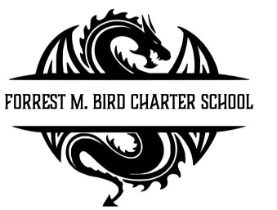
Board Meeting
Forrest M. Bird Charter High School
615 S. Madison,
Sandpoint, ID 83864
Date: Dec 5th , 2025

 | Board Meeting Minutes - Disciplinary Meeting
Minutes taken by | Collin Day
Board members Present | Susan Roberts, Alisha Kowalski, Shawn Burns, Stephanie Hawkins
Excused Board Members
Staff present | Mary Jensen, Shainnie Wade
Guests
Call to Order | Meeting Called to Order at 3:05; Quorum established at 3:05

Public Comment | - None
Student A: Truancy | Action Item: Motion to enter Executive Session – 3:06  Approval:  Motioned – Stephanie Hawkins  2nd – Susan Roberts  Approved Unanimously  Motion to invite Mary Jensen to attend Executive Session  Approval:  Motioned – Stephanie Hawkins  2nd – Susan Roberts  Approved Unanimously  - Read written description of incident from principal  - Neither Student A nor guardian attended  - Student A disruptive to other students, not attending  Action Item: Motion to exit Executive Session – 3:24  Approval:  Motioned – Alisha Kowalski  2nd – Stephanie Hawkins  Approved Unanimously  Action Item: Motion to Expel Student A  Approval:  Motioned – Stephanie Hawkins  2nd – Alisha Kowalski  Approved Unanimously

Student B: Possession of Illegal Substance on School Grounds | Action Item: Motion to enter Executive Session – 3:26  Approval:  Motioned – Stephanie Hawkins  2nd – Alisha Kowalski  Approved Unanimously  Motion to invite Mary Jensen to attend Executive Session  Approval:  Motioned – Stephanie Hawkins  2nd – Susan Roberts  Approved Unanimously  - First offense – precedent to allow student to go on board behavior plan  - Was not trying to actively distribute  Action Item: Motion to exit Executive Session – 4:03  Approval:  Motioned – Collin Day  2nd – Stephanie Hawkins  Approved Unanimously  Action Item: Motion to have Student B on board plan, require vaping class, and self reflection – will return to board after class to report  Approval:  Motioned – Stephanie Hawkins  2nd – Collin Day  Approved Unanimously
Adjournment | Meeting adjourned at 4:05 pm  - Motion to adjourn – Stephanie Hawkins  - 2nd – Collin Day  Approved Unanimously

Next Board Meeting | January 29th, 2026

Respectfully Submitted: Mary J. Jensen

Date:

Signed:____________________________
Board Chair, date

Signed: ___________________________

Board Secretary, date

