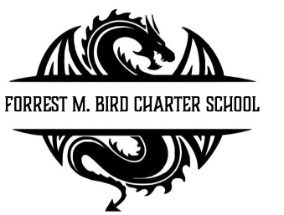
Board Meeting
Forrest M. Bird Charter High School
615 S. Madison,
Sandpoint, ID 83864
Date: Nov 20th , 2025

 | Board Meeting Minutes
Minutes taken by | Collin Day
Board members Present | Susan Roberts, Alisha Kowalski, Shawn Burns, Stepanie Hawkins
Excused Board Members
Staff present | Mary Jensen, Gretta Warren
Guests
Call to Order | Meeting Called to Order at 4:33; Quorum established at 4:32
Minutes | Action Item: Approval of October 23, 2025 Board meeting minutes @ 4:38  - Motioned – Alisha Kowalski  - 2nd – Stephanie Hawkins  Approved Unanimously

Public Comment | - None
Financials | Action Item: Approval of Financial Reports – Greta Warren  Approval:  Motioned – Alisha Kowalski  2nd – Stephanie Hawkins  Approved Unanimously  Action Item: Close Mountain West Contingency Account – Greta Warren  - Moving to a better account  Approval:  Motioned – Stephanie Hawkins  2nd – Alisha Kowalski  Approved Unanimously  Information: Upcoming Budgeting work – Greta Warren

Open Business | Action Item: Cody Thompson - Petition to be considered to join the board  - Cancelled – Cody had an immediate issue to deal with.
Adjournment | Meeting adjourned at 5:02 pm  - Motion to adjourn – Stephanie Hawkins  - 2nd – Alisha Kowalski  Approved Unanimously

Next Board Meeting | January 29th, 2026

Respectfully Submitted: Mary J. Jensen

Date:

Signed:____________________________
Board Chair, date

Signed: ___________________________

Board Secretary, date

