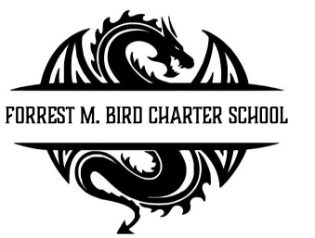

Board Meeting
Forrest M. Bird Charter High School
615 S. Madison,
Sandpoint, ID 83864
Date: Sept 25th , 2025

 | Board Meeting Minutes
Minutes taken by | Collin Day
Board members Present | Susan Roberts, Alisha Kowalski, Shawn Burns, Stephanie Hawkins
Excused Board Members
Staff present | Mary Jensen, Gretta Warren
Guests | Kevin Smith of Hayden Ross, PLLC
Call to Order | Meeting Called to Order at 4:37; Quorum established at 4:37
Minutes | Action Item: Approval of August 21st 2025 Board meeting minutes @ 4:38  - Motioned – Alisha Kowalski  - 2nd – Susan Roberts  Approved Unanimously

Public Comment | - None
Financials | Action item: Audit Report – note, motion to switch order from agenda to accommodate guest speaker, Motioned, Collin Day, 2nd Susan Roberts, Unanimous Approval  Discussion: Review yearly audit – no concerns raised  Approval  - Motioned – Collin Day  - 2nd – Alisha Kowalski  Approved Unanimously  Action Item: Approval of Financial Records  Discussion: Warning that current financial status may differ from projections based on current enrollment, more data will be available after there has been time to generate data.  Approval:  Motioned – Susan Roberts  2nd – Collin Day  Approved Unanimously

Open Business | Action Item – Toyota Tacoma Sale  - Sell Tacoma due to financials – Approx 40K projected  - Buy Tundra From Bonnie Jakubos - cost 4K  Approval  - Motioned – Stephanie Hawkins  - Second – Susan Roberts  Approved Unanimously  Action Item – FBCS Bylaws Adoption  - No further changes requested  - Approval:  - Motioned – Stephanie Hawkins  - Second – Susan Roberts  Approved Unanimously  Action Item – Continuous Plan of Improvement  Approval:  - Motioned – Collin Day  - Second – Stephanie Hawkins  Approved Unanimously
Adjournment | Meeting adjourned at 5:38 pm  - Motion to adjourn – Collin Day  - 2nd – Susan Roberts  Approved Unanimously

Next Board Meeting | October 23rd, 2025

Respectfully Submitted: Colin Day

Date: Sept. 28, 2025

Signed:____________________________
Board Chair, date

Signed: ___________________________

Board Secretary, date

