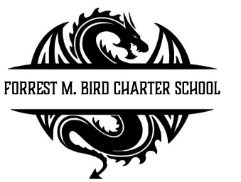
Board Meeting
Forrest M. Bird Charter High School
615 S. Madison,
Sandpoint, ID 83864
Date:

 | Board Meeting Minutes
Minutes taken by | Collin Day
Board members Present | Shawn Burns, Stephanie Hawkins, Susan Roberts, Alisha Kowalski
Excused Board Members
Staff present | Mary Jensen, Greta Warren
Guests
Call to Order | Meeting Called to Order at 4:30; Quorum established at 4:30
Minutes | Action Item: Approval of November 19th 2024 Board meeting minutes @ 4:35  - Motioned – Stephanie Hawkins  - 2nd – Susan Roberts  Approved Unanimously

Executive Session | - None
Public Comment | - None
Financials | Action item: Financial reports approval  Discussion: Normal school finances  Approval  - Motioned – Susan Roberts  - 2nd – Stephanie Hawkins  Approved Unanimously  Action item: Revenue and Expenditure statement approval  Discussion:  Approval  - Motioned – Stephanie Hawkins  - 2nd – Susan Roberts  Approved Unanimously

Open Business | Action item: Alisha Kowalski to join board  Discussion: Possible move of meeting times to accommodate other good works  Approval  - Motioned – Stephanie Hawkins  - 2nd – Susan Roberts  Approved Unanimously  Action item: Update cell phone policy to align with new state policy  Approval  - Motioned – Susan Roberts  - 2nd – Alisha Kowalski  Approved Unanimously  Action item: Open enrollment period to start one week earlier this year  Discussion:  Approval  - Motioned – Alisha Kowalski  - 2nd – Stephanie Hawkins  Approved Unanimously  Action item: Priest River Bus Route  Discussion: Contingent on having enough students to support route.  Approval  - Motioned – Collin Day  - 2nd – Alisha Kowalski  Approved Unanimously  Action item: Van Permit for Blake W.  Discussion:  Approval  - Motioned – Susan Roberts  - 2nd – Stephanie Hawkins  Approved Unanimously  Action item: Unpaid leave of absence for Andrea Nye  Approval  - Motioned – Alisha Kowalski  - 2nd – Stephanie Hawkins  Approved Unanimously  Action item: Newspaper Club Approval  Approval  - Motioned – Collin Day  - 2nd – Stephanie Hawkins  Approved Unanimously
Adjournment | Meeting adjourned at 5:40 pm  - Motion to adjourn – Alisha Kowlaski  - 2nd – Susan Roberts  Approved Unanimously

Next Board Meeting | Feb 11, 2025

Respectfully Submitted: Mary J. Jensen

Date:

Signed:____________________________
Board Chair, date

Signed: ___________________________

Board Secretary, date

