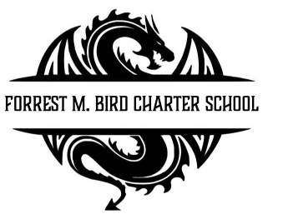

Board Meeting

Forrest M. Bird Charter High School

615 S. Madison,

Sandpoint, ID 83864

Date: Nov. 19, 2024

|  |  |
| --- | --- |
|  | Board Meeting Minutes |
| Minutes taken by | Collin Day |
| Board members Present | Shawn Burns, Stephanie Hawkins, Susan Roberts, Collin Day |
| Excused Board Members |  |
| Staff present | Mary Jensen, Greta Warren |
| Guests | Alicia Kowalski |
| Call to Order | Meeting Called to Order at 4:40pm; Quorum established at 4:40pm |
| Minutes | **Action Item:** Approval of Oct 30, 2024 Board meeting minutes   * Motioned – Stephanie Hawkins * 2nd – Susan Roberts   Approved Unanimously |

|  |  |
| --- | --- |
| Executive Session | * No Executive Session |
| Public Comment | * No public comment |
| Financials | ***Action item:*** *Approve Financial Reports – Greta Warren*  Discussion: Greta to come up with method to give idea of if we at about the right place with budget at given point in time.  Approval   * Motioned – Susan Roberts * 2nd – Stephanie Hawkins   Approved Unanimously  ***Action item:*** *Approval of Revenue and Expenditure Statements – Greta Warren*  Discussion: No Discussion  Approval   * Motioned – Stephanie Hawkins * 2nd – Susan Roberts   Approved Unanimously |
|  |  |

|  |  |
| --- | --- |
| Open Business | ***Action item:*** *Stem Diploma – Mary J. Jensen*  Discussion: Review of new STEM diploma requirements  Approval   * Motioned – Stephanie Hawkins * 2nd – Collin Day   Approved Unanimously |
| Adjournment | Meeting adjourned at 5:55 pm   * Motion to adjourn – Susan Roberts * 2nd – Stephanie Hawkins   Approved Unanimously |

|  |  |
| --- | --- |
| Next Board Meeting | 28-01-2024 |

Respectfully Submitted: Collin Day

Date: November 20, 2024

Signed:____________________________

Board Chair, Date

Signed: ___________________________

Board Secretary, Date