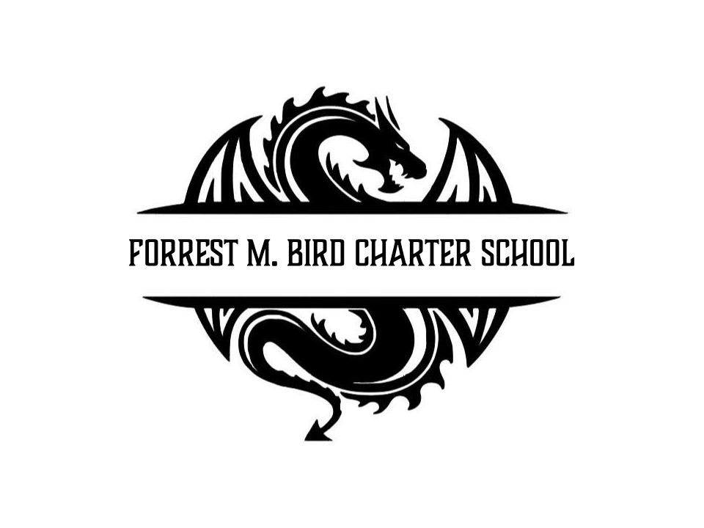
Board Meeting
Forrest M. Bird Charter High School
615 S. Madison,
Sandpoint, ID 83864
Date: October 30, 2024

 | Board Meeting Minutes
Minutes taken by | Mary J. Jensen
Board members Present | Shawn Burns, Stephanie Hawkins, Collin Day, Susan Roberts
Excused Board Members
Staff present | Mary Jensen, Greta Warren
Guests | Alicia Kowalski
Call to Order | Meeting Called to Order at 4:30pm
Minutes | Action Item: Approval of Sept. 17, 224 Board meeting minutes  - Motioned – Stephanie Hawkins  - 2nd – Susan Roberts  Approved Unanimously

Public Comment | - No public comment
Financials | Action Item: Financial Reports  - Motioned – Susan Roberts  - 2nd – Stephanie Hawkins  Approved Unanimously  Action Item: Approval of Revenues and Expenditures Statement  - Motioned – Collin Day  - 2nd – Stephanie Hawkins  Approved Unanimously

Open Business | Action item: Special Education Paraprofessional hire – Brittany Twomey  Approval  - Motioned – Collin Day  - 2nd – Stephanie Hawkins  Discussion: With the increase of our special education population to 27% this year, additional paraprofessionals are needed in the special education department. This was not budgeted this year. If needed, we can use the contingency fund at the end of the year to help fund this additional position if needed.  Approved Unanimously  Action Item: 2024 Special Education Manual  - Motioned – Collin Day  - 2nd – Stephanie Hawkins  Approved Unanimously  Action Item: FBCS Vehicle Driver – Misty Rains  - Motioned – Susan Roberts  - 2nd – Stephanie Hawkins  Approved Unanimously  Action Item: Blakey Wilkins Alternate Authorization  - Motioned – Stephanie Hawkins  - 2nd – Susan Roberts  Note: Mr. Wilkins obtained a history certification from the state. Because he is teaching government and economics, he will need to take a Praxis test to add Social Studies to his certification. The Alternate Authorization will allow for him to teach Social Studies until he can take the Praxis Test.  Approved Unanimously  Action Item: Rachel Askew Alternate Authorization for High School Theater Arts  - Motioned – Stephanie Hawkins  - 2nd – Susan Roberts  Approved Unanimously  Information: Graduation Requirements  The State Graduation requirements will most likely change during the state legislative session. FBCS will begin looking at not only incorporating the new graduation requirements but also reviewing if FBCS requirements should change. This will be done through input sessions with staff, families, and students. Once complete, the proposed changes will be presented to the Board.
Adjournment | Meeting adjourned at 5:15pm  - Motion to adjourn – Collin Day  - 2nd – Susan Roberts  Approved Unanimously

Respectfully Submitted: Mary J. Jensen

Date: November 19, 2024

Signed:____________________________
Shawn Burns, 11/19/24

Signed: ___________________________
Mary Jensen, 11/19/24

